## B3-Aparna Bharathi Suresh

### Single page application:

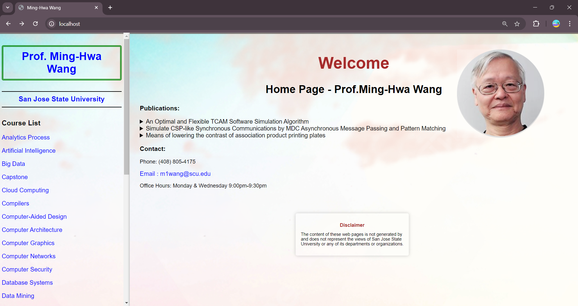

### Click on Web Programming url changes to /web

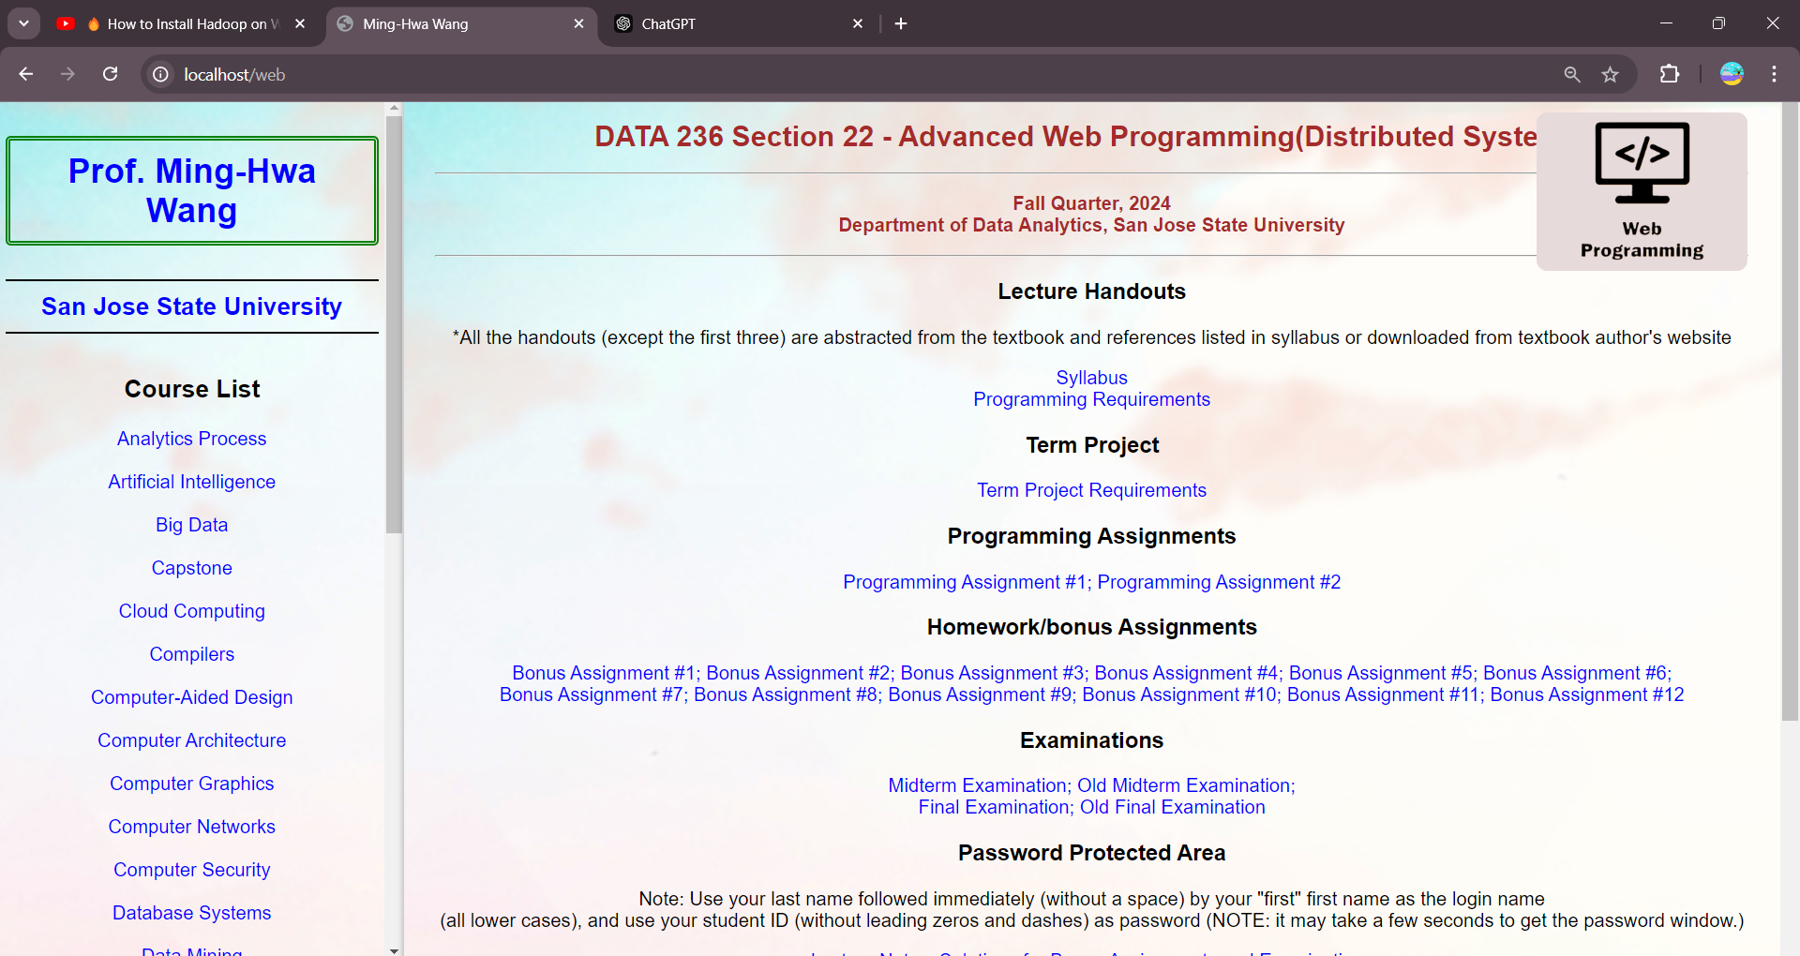

### Web Programming is highlighted when we hover it

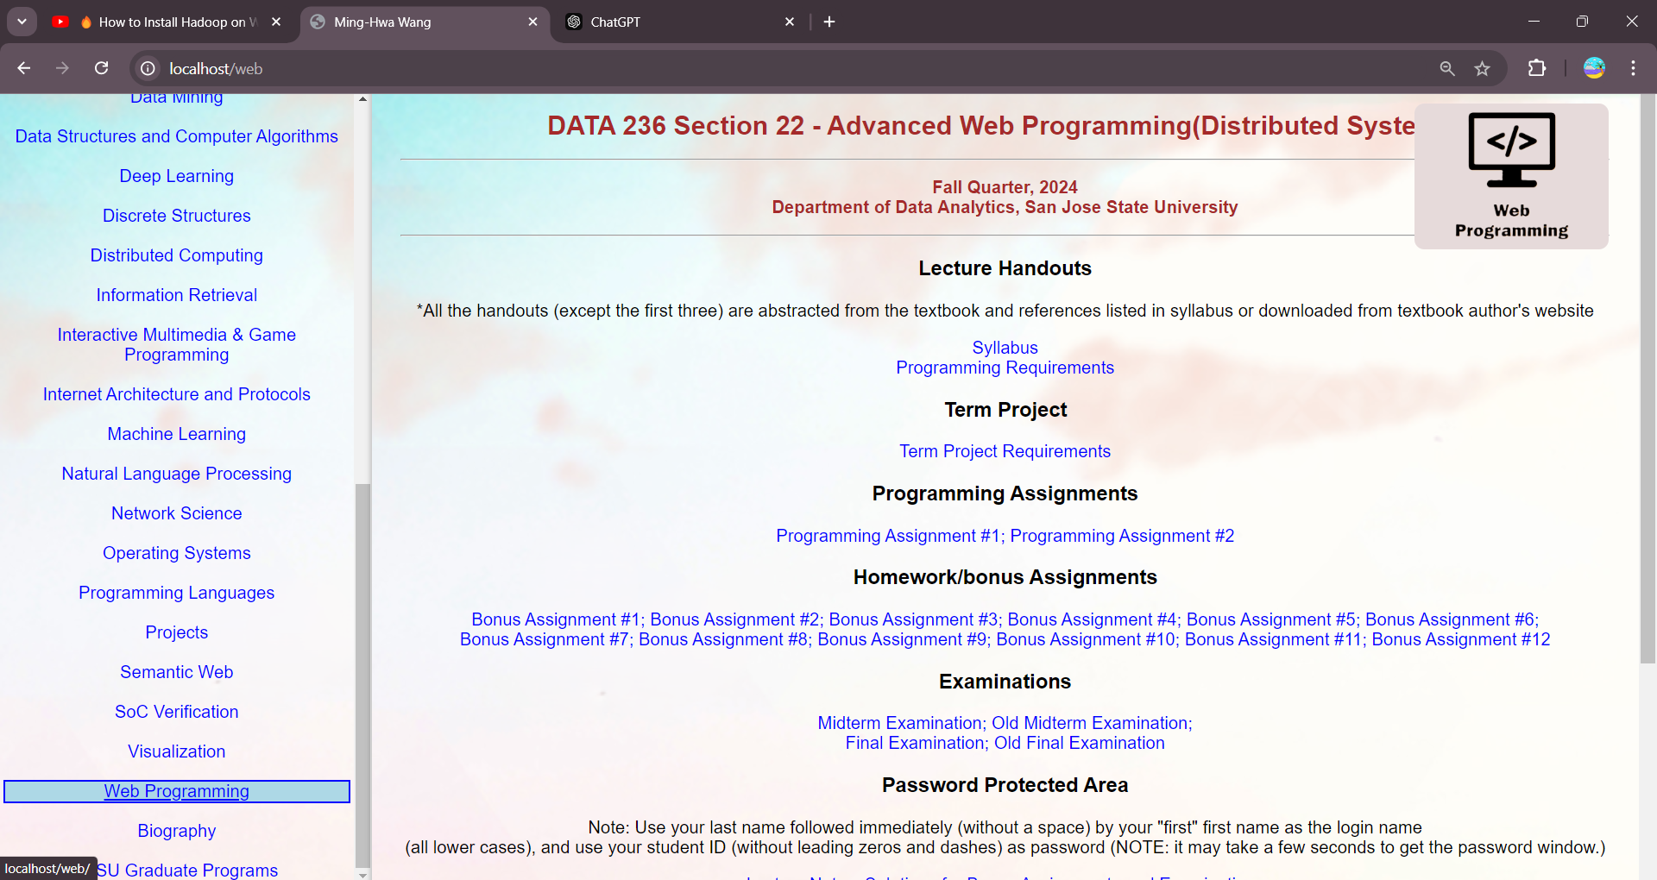

### Full page of Web Programming

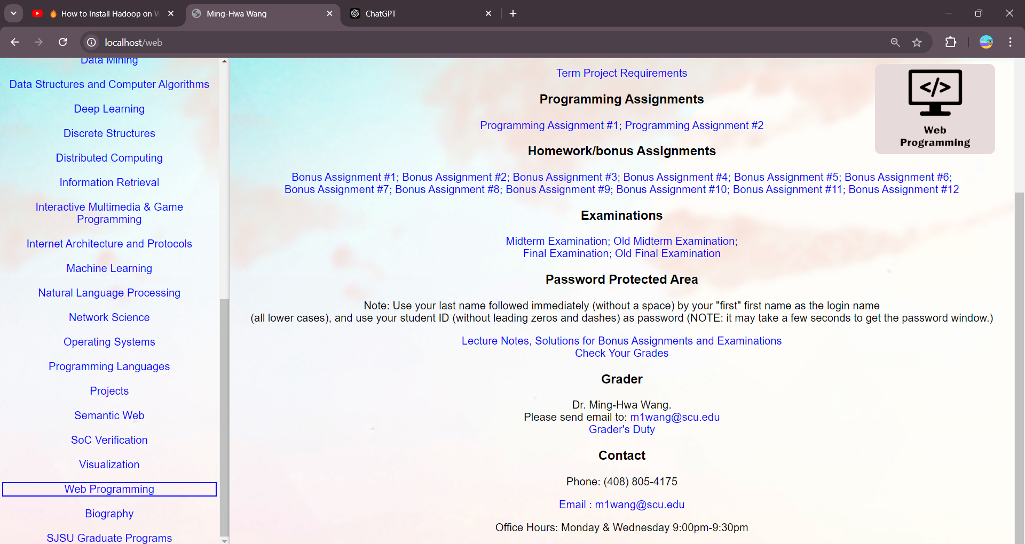

### Hover on back button in the browser:

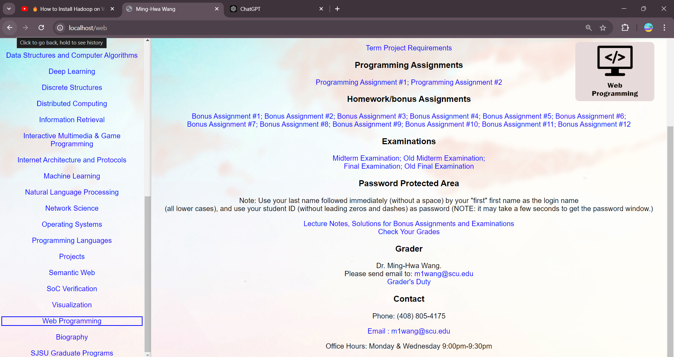

### Click on back button it goes to homepage and /web id gone in the url

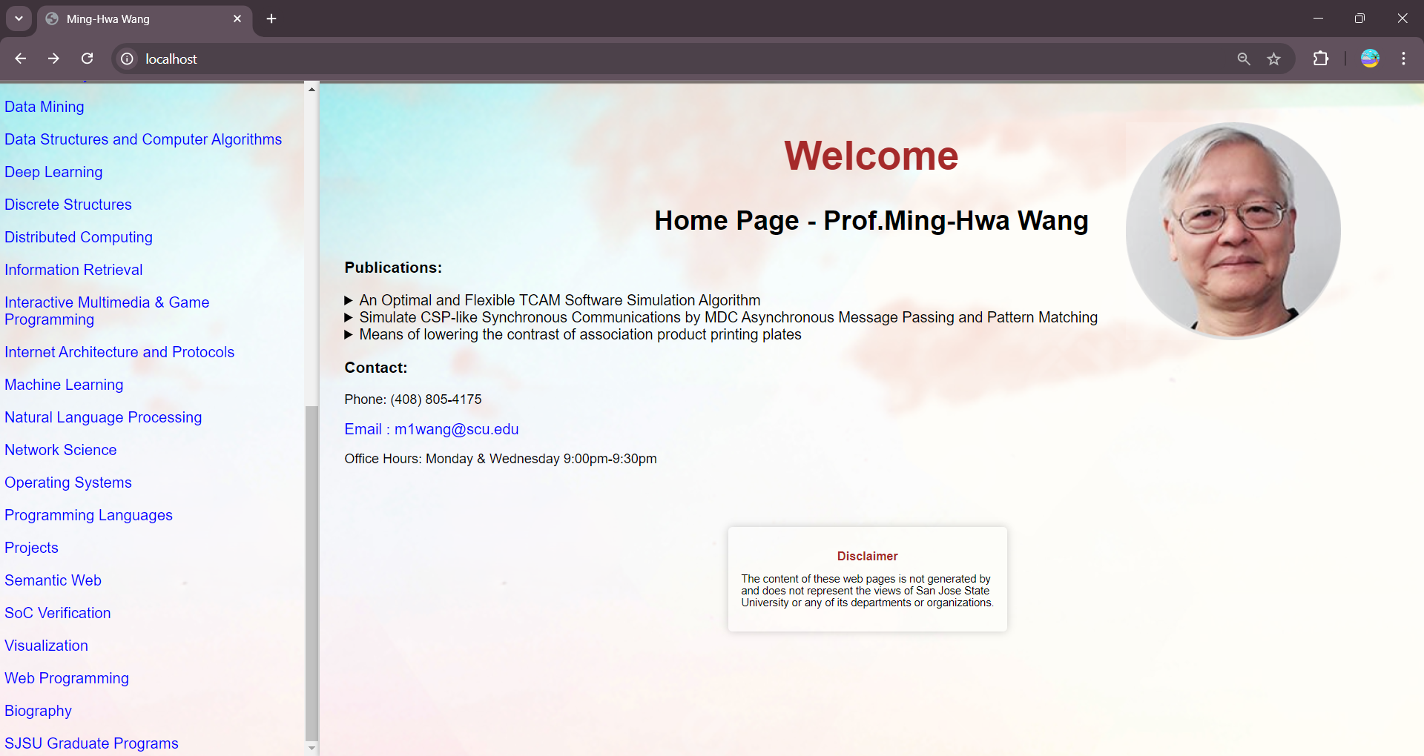

### Hover on forward button:

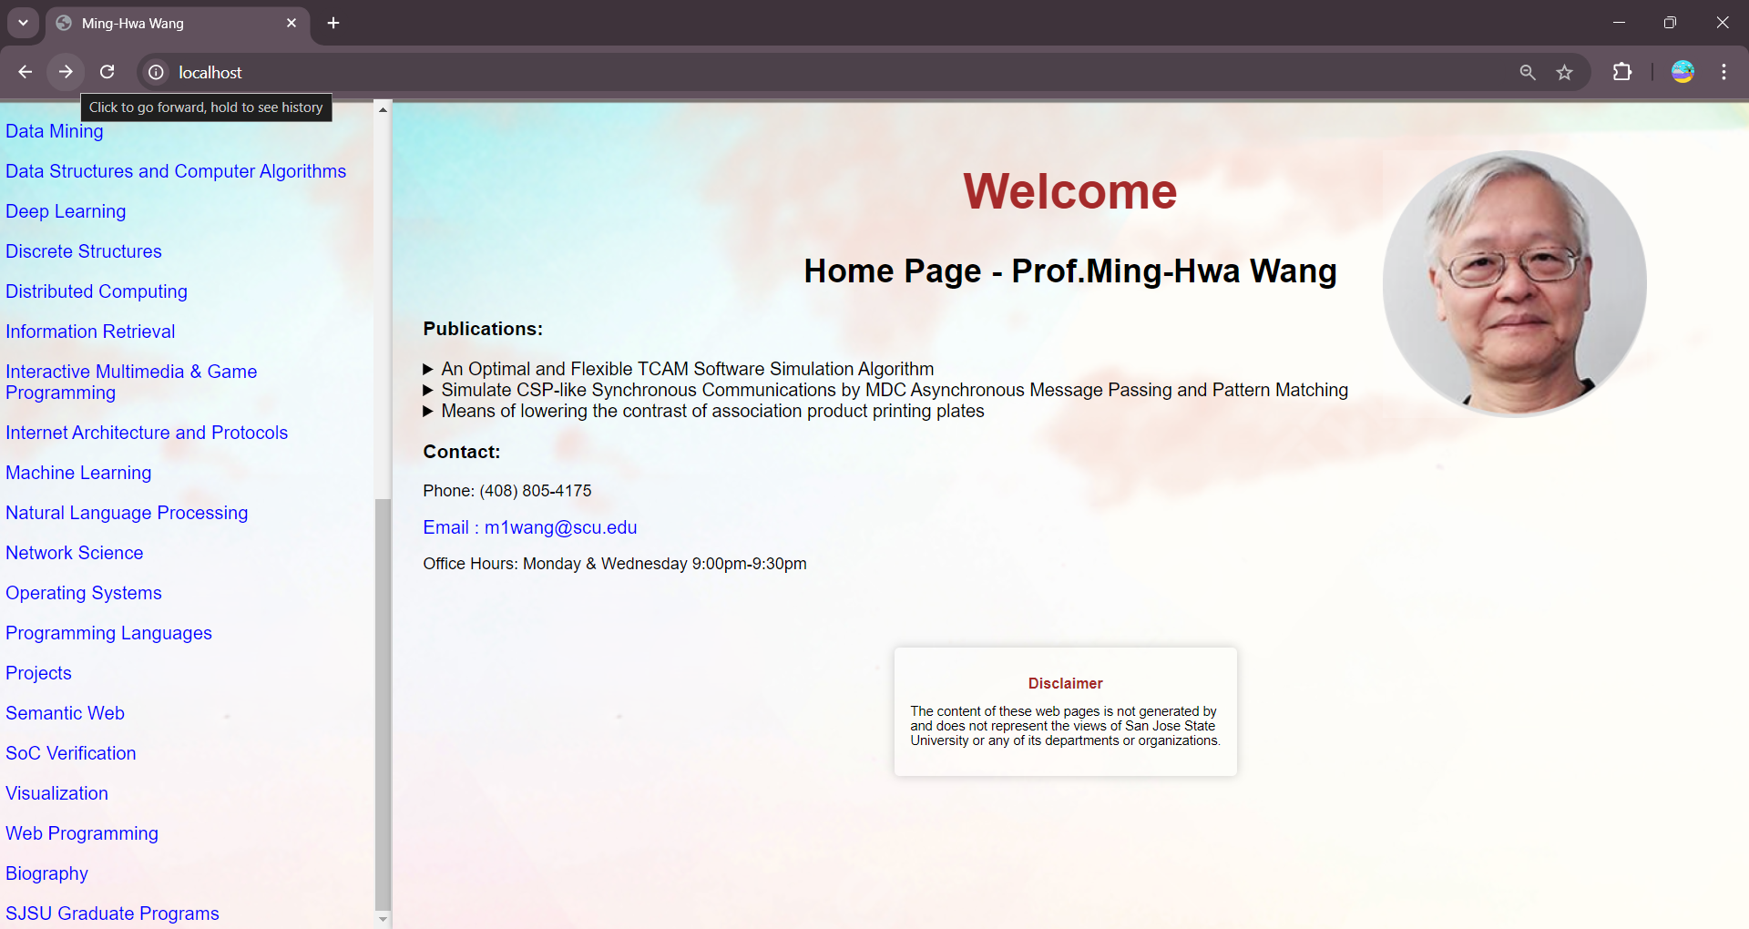

### It goes to web programming page when clicked on forward button:

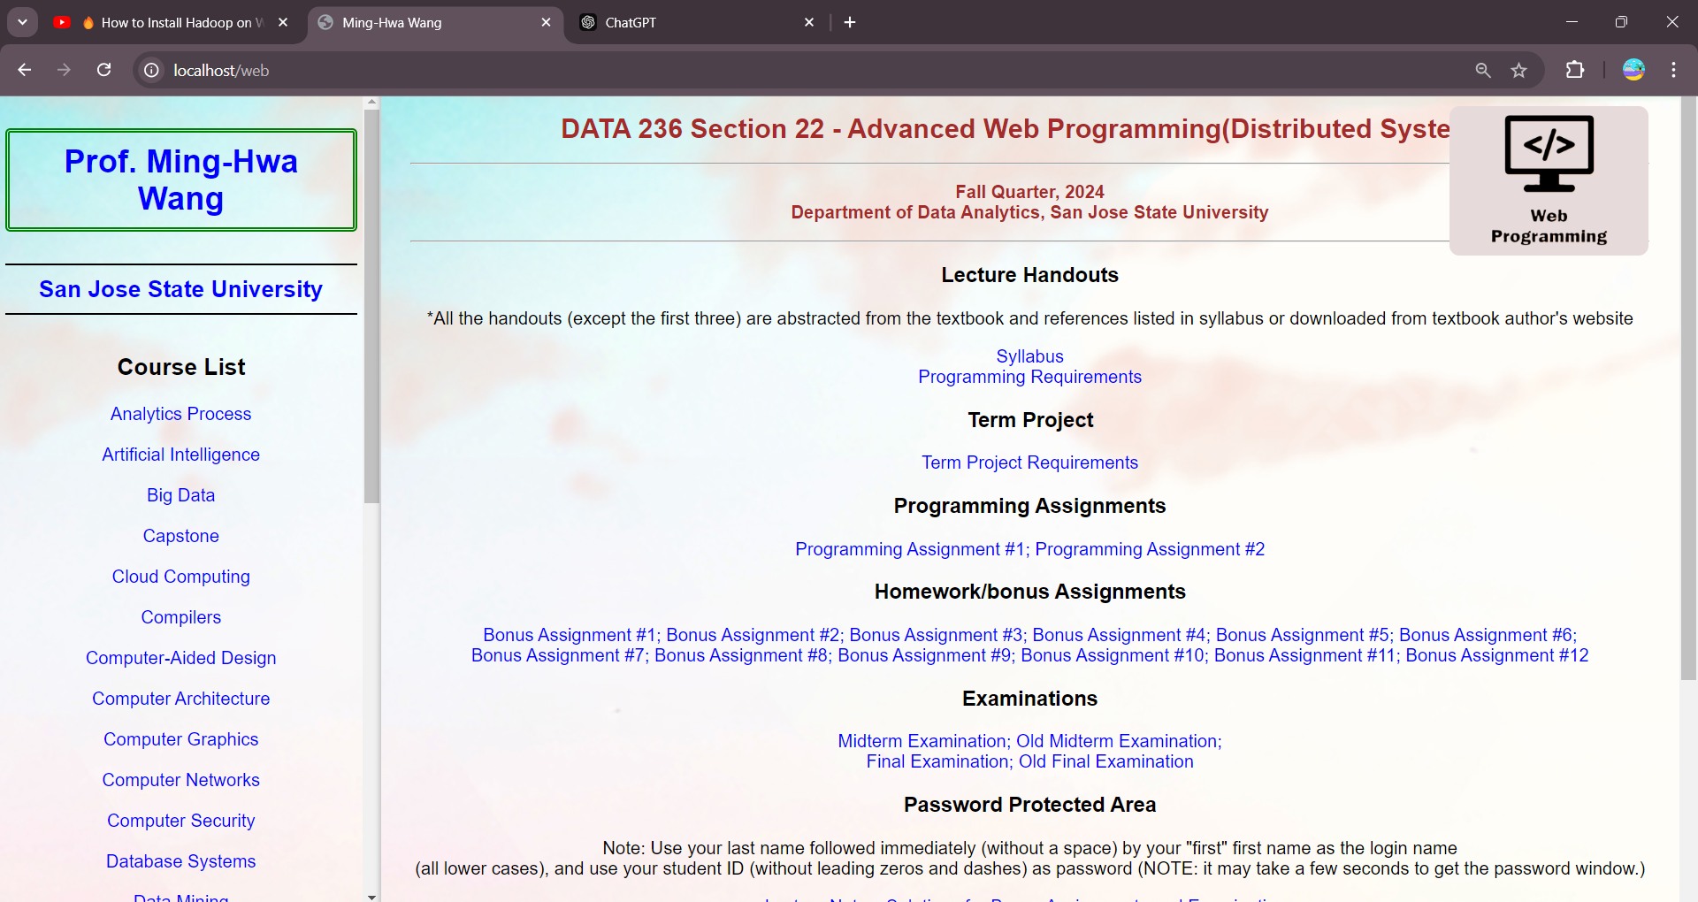

### Bookmark the home page

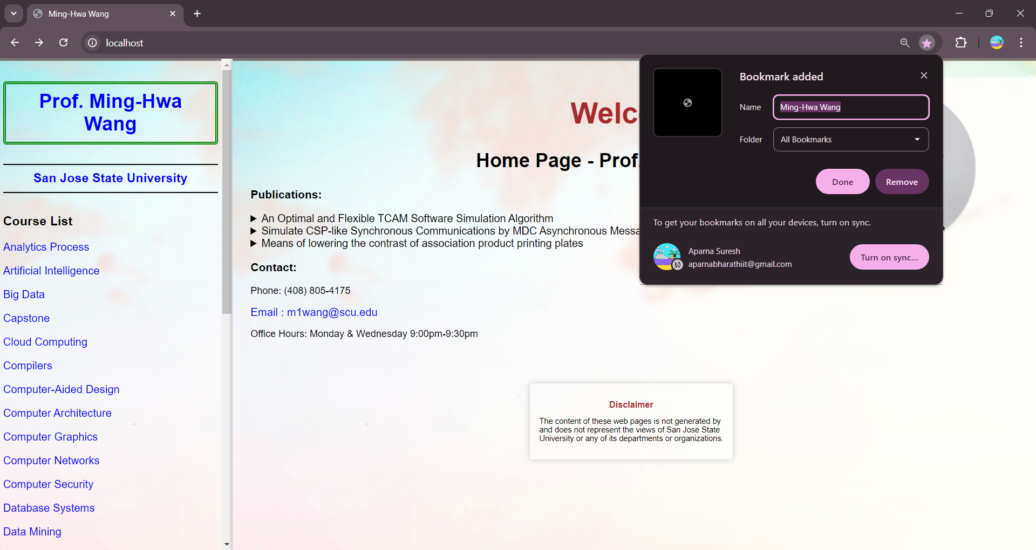

### Click on the bookmarked page

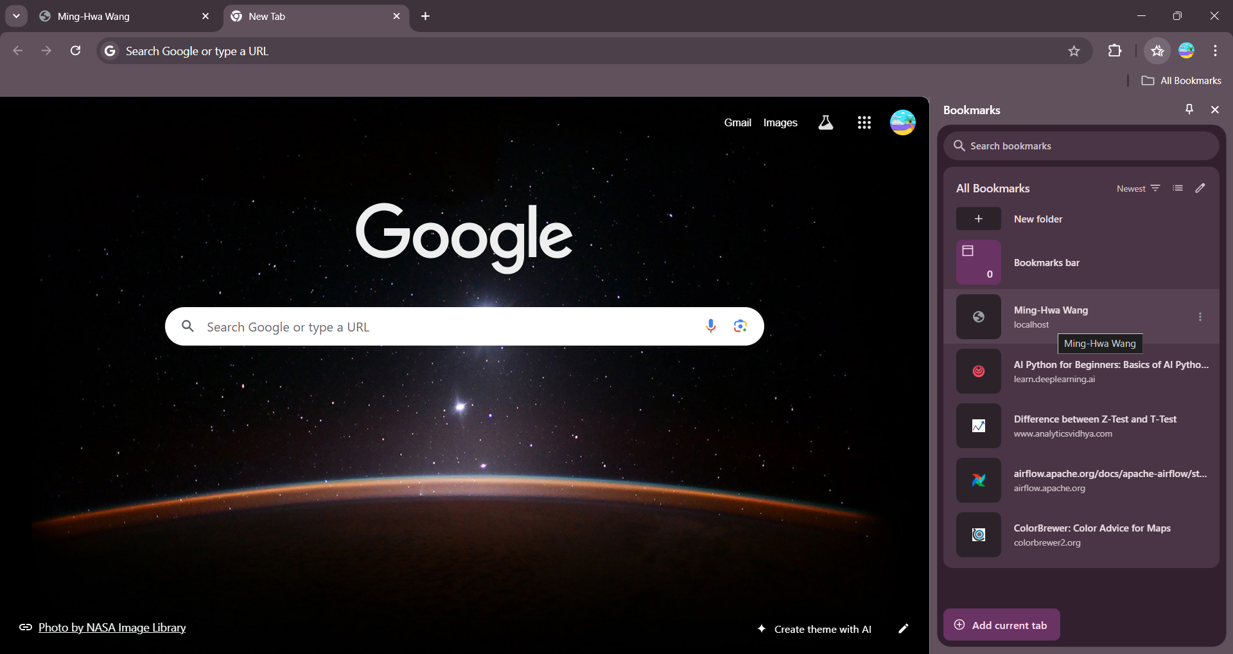

### Homepage is opened from the bookmark:

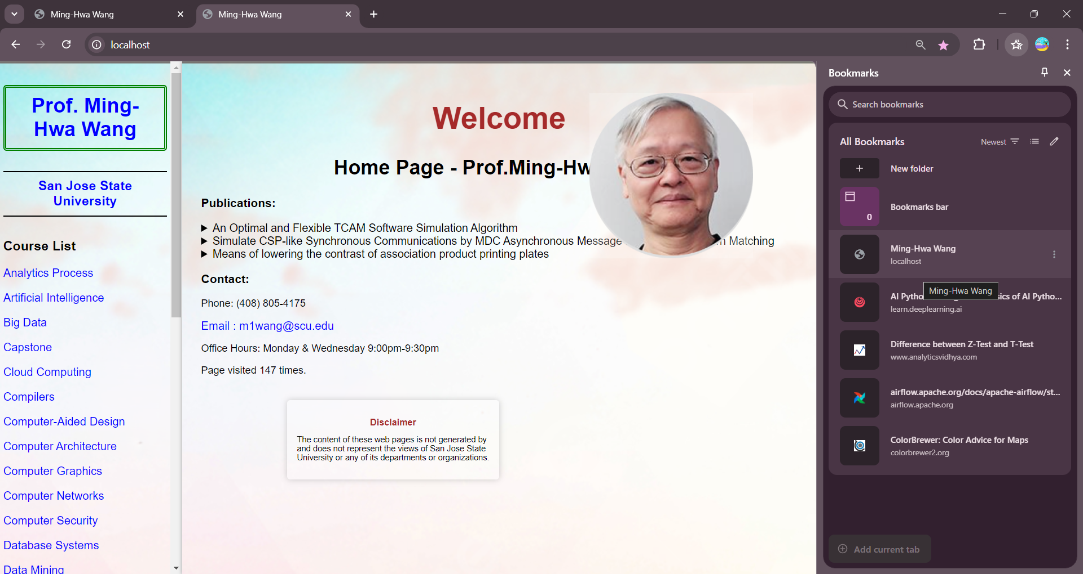

### Document Structure:

Htdocs

|- .htaccess # Configuration file

|- index.html # Main HTML file

|- Behavior # JavaScript Directory

|-script.js

|- File

|-AwardBio.pdf #Biography source file

|- Presentation # Directory for CSS files

|-style.css

|-WebProgramming.css

|-Images

|-Backdrop.PNG

|-Backdrop-1.PNG

|-Ming-Hwa-Wang-PhD.PNG

|-web-programming.JPG

|- Structure

|-WebProgramming.html #WebProgramming page

|-Home.html #Home Page Structure

### Screenshot of htdocs:

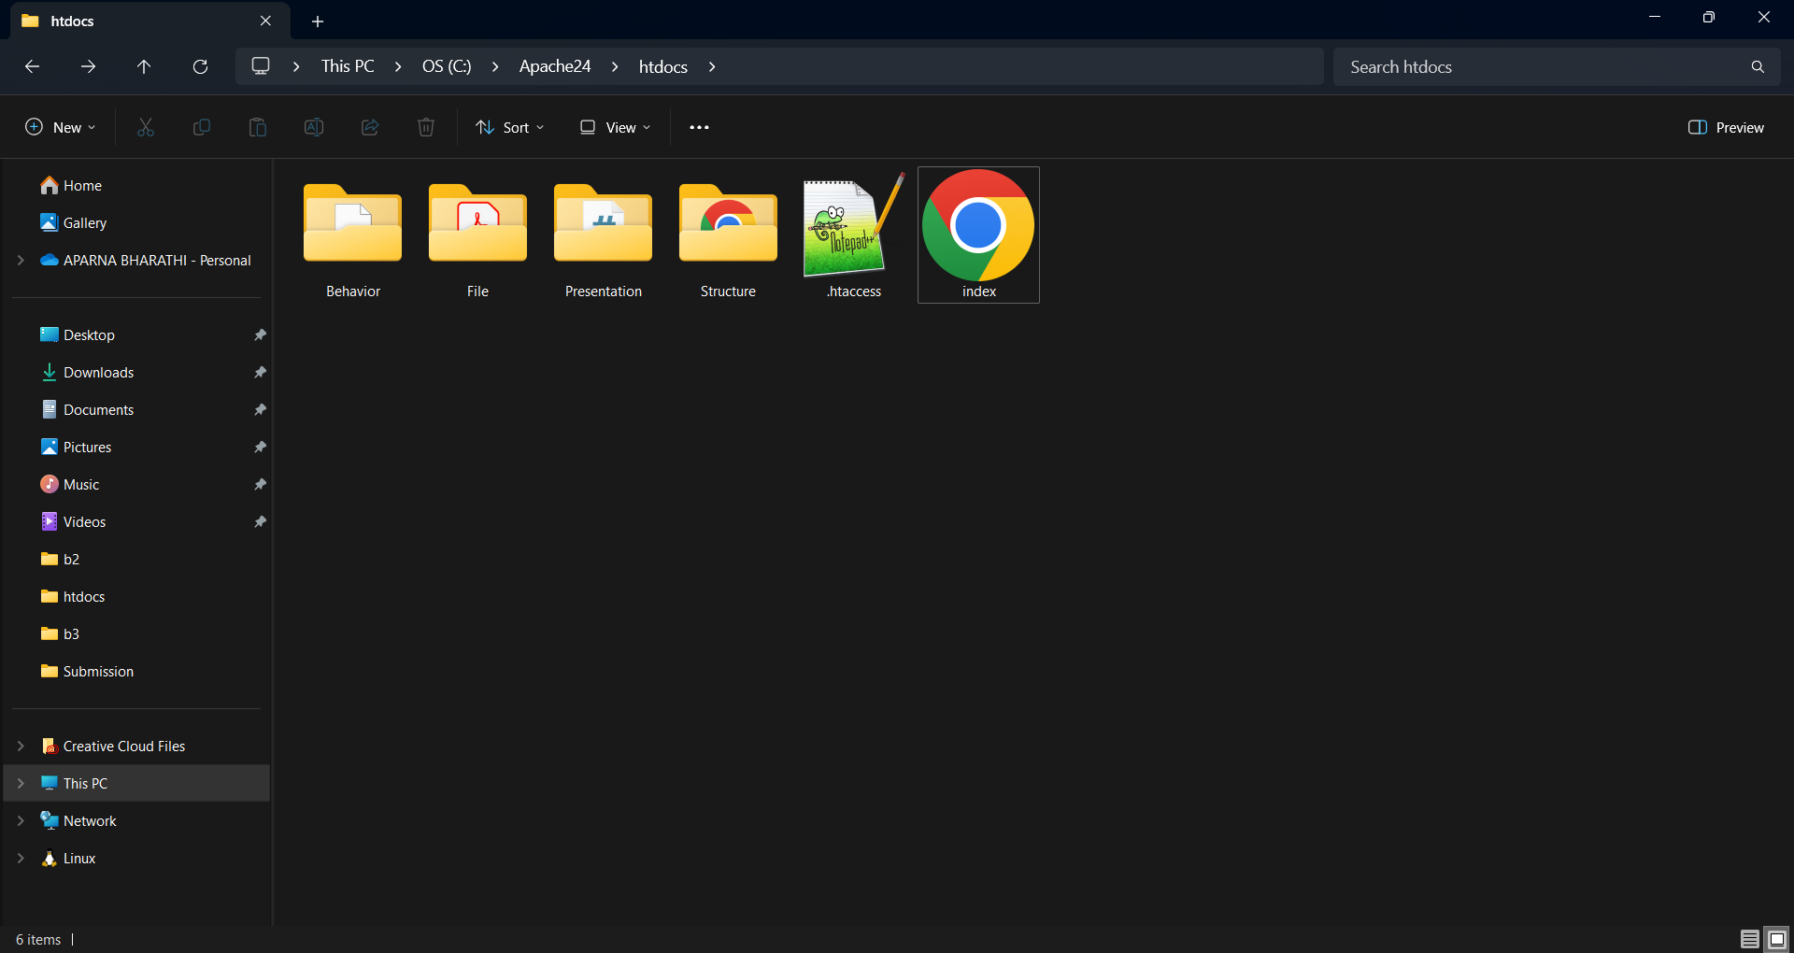

### Presentation

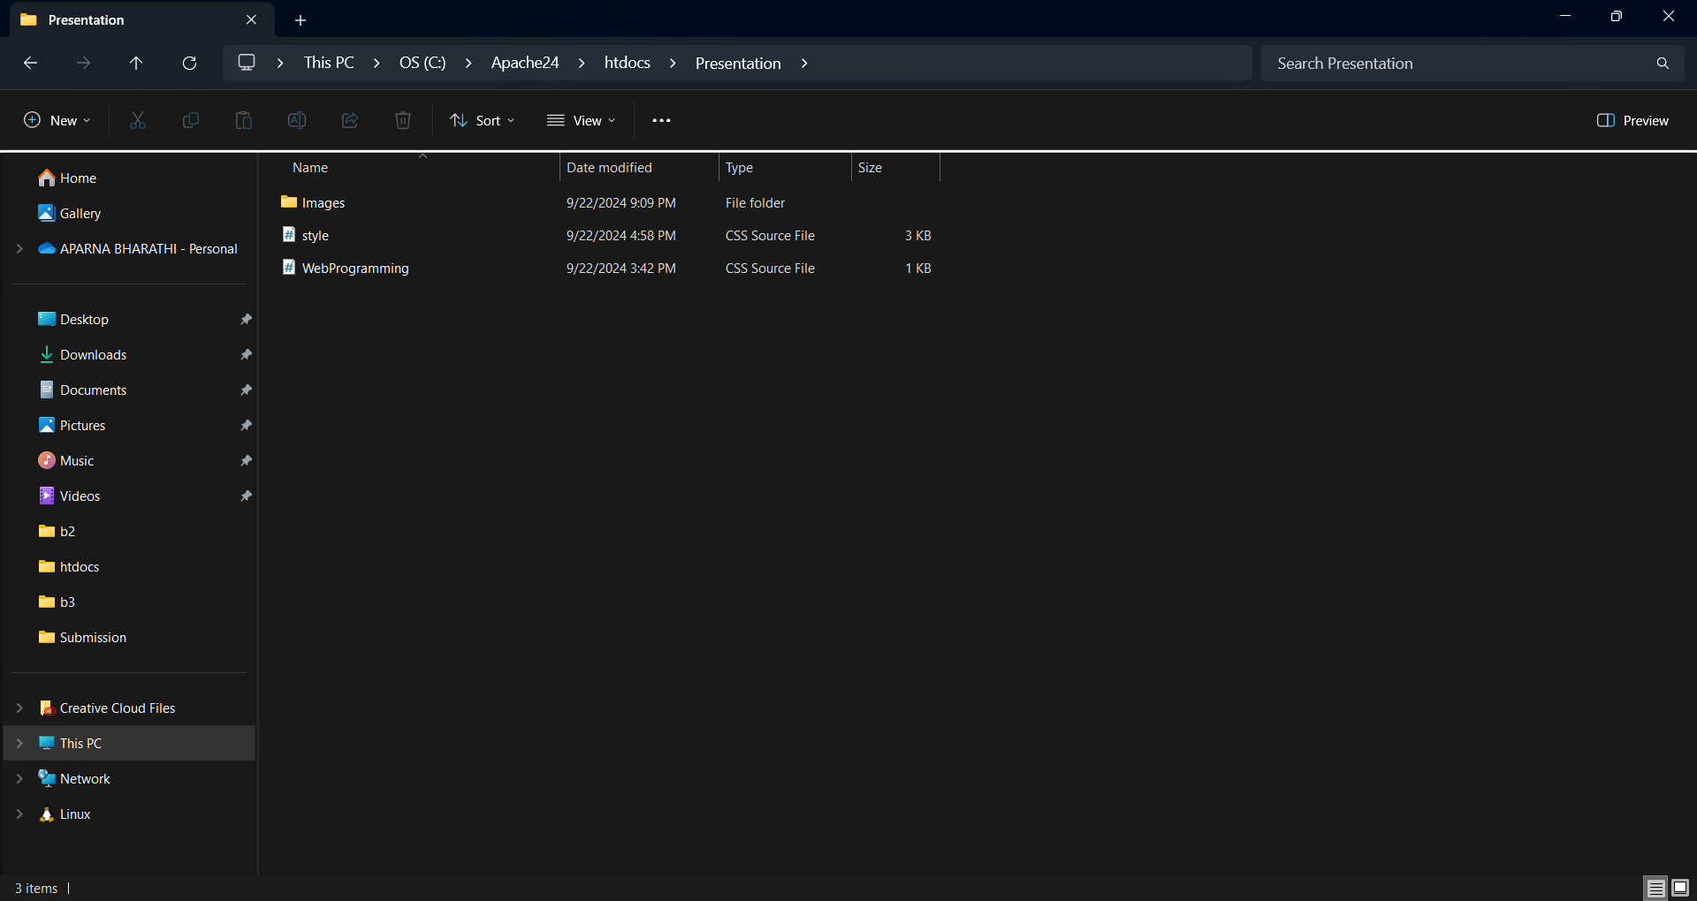

### Structure:

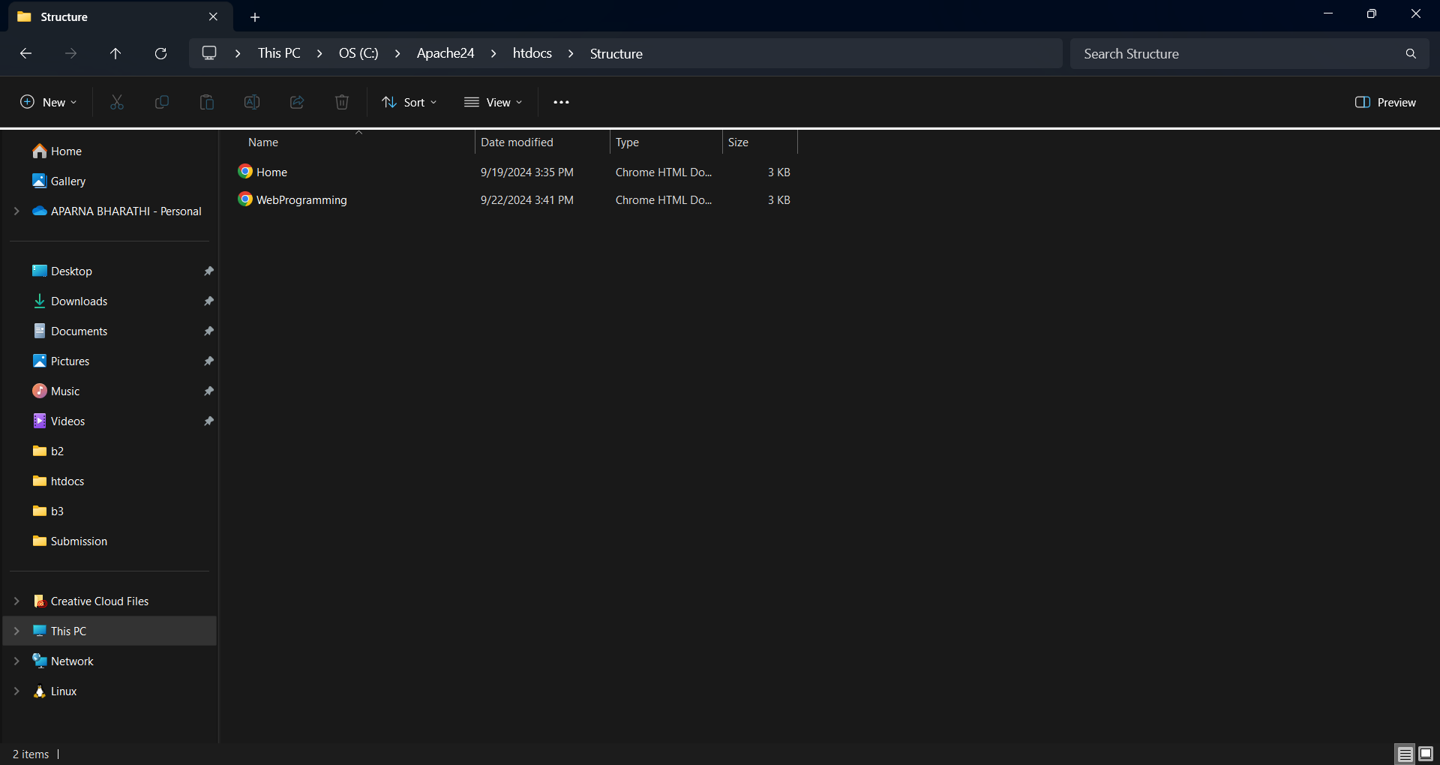

Behavior:

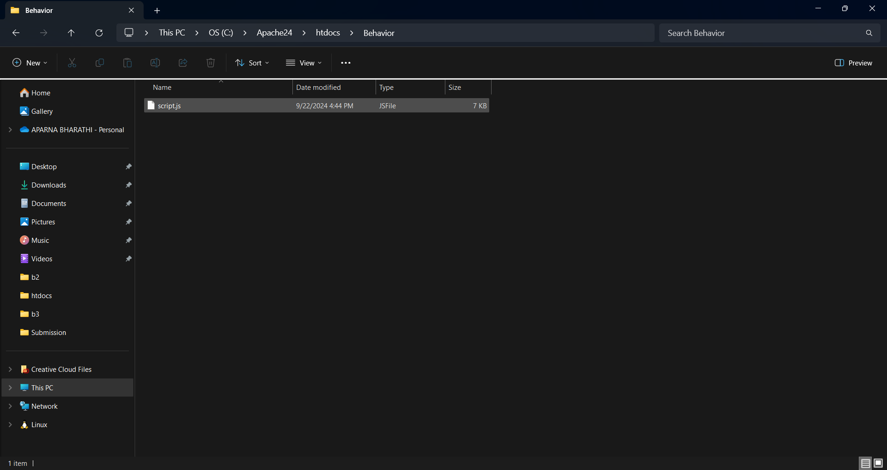

### File:

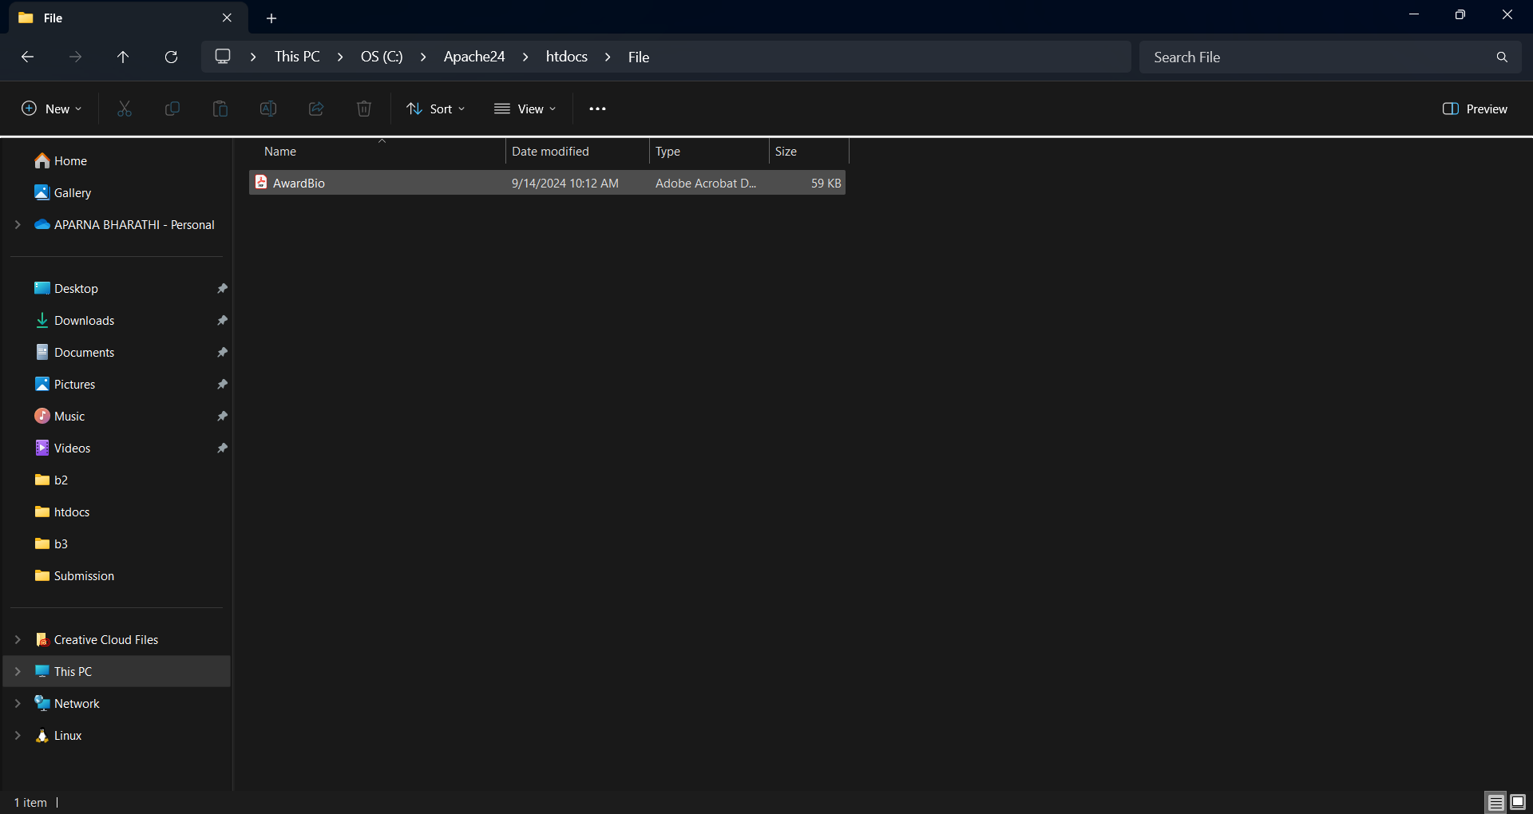

### Page Hits:

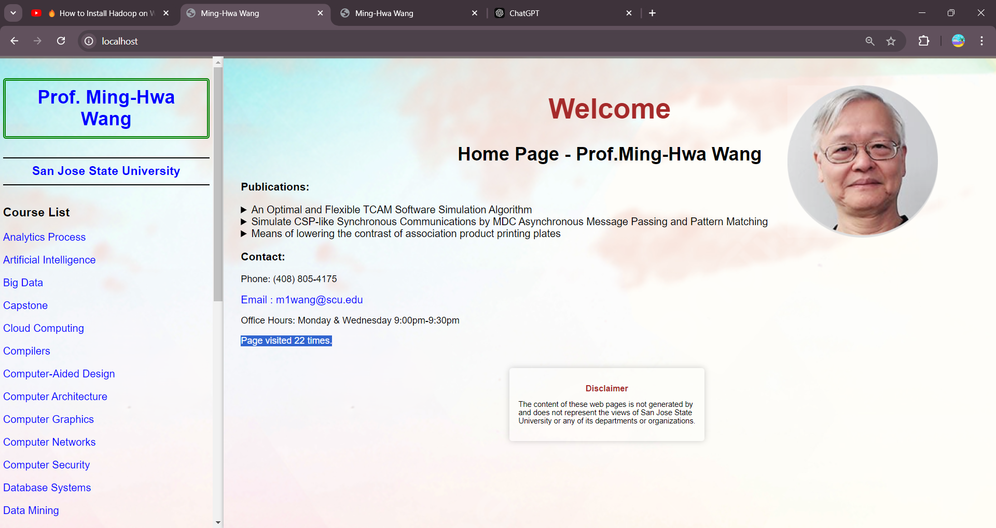

### Increment page hits:

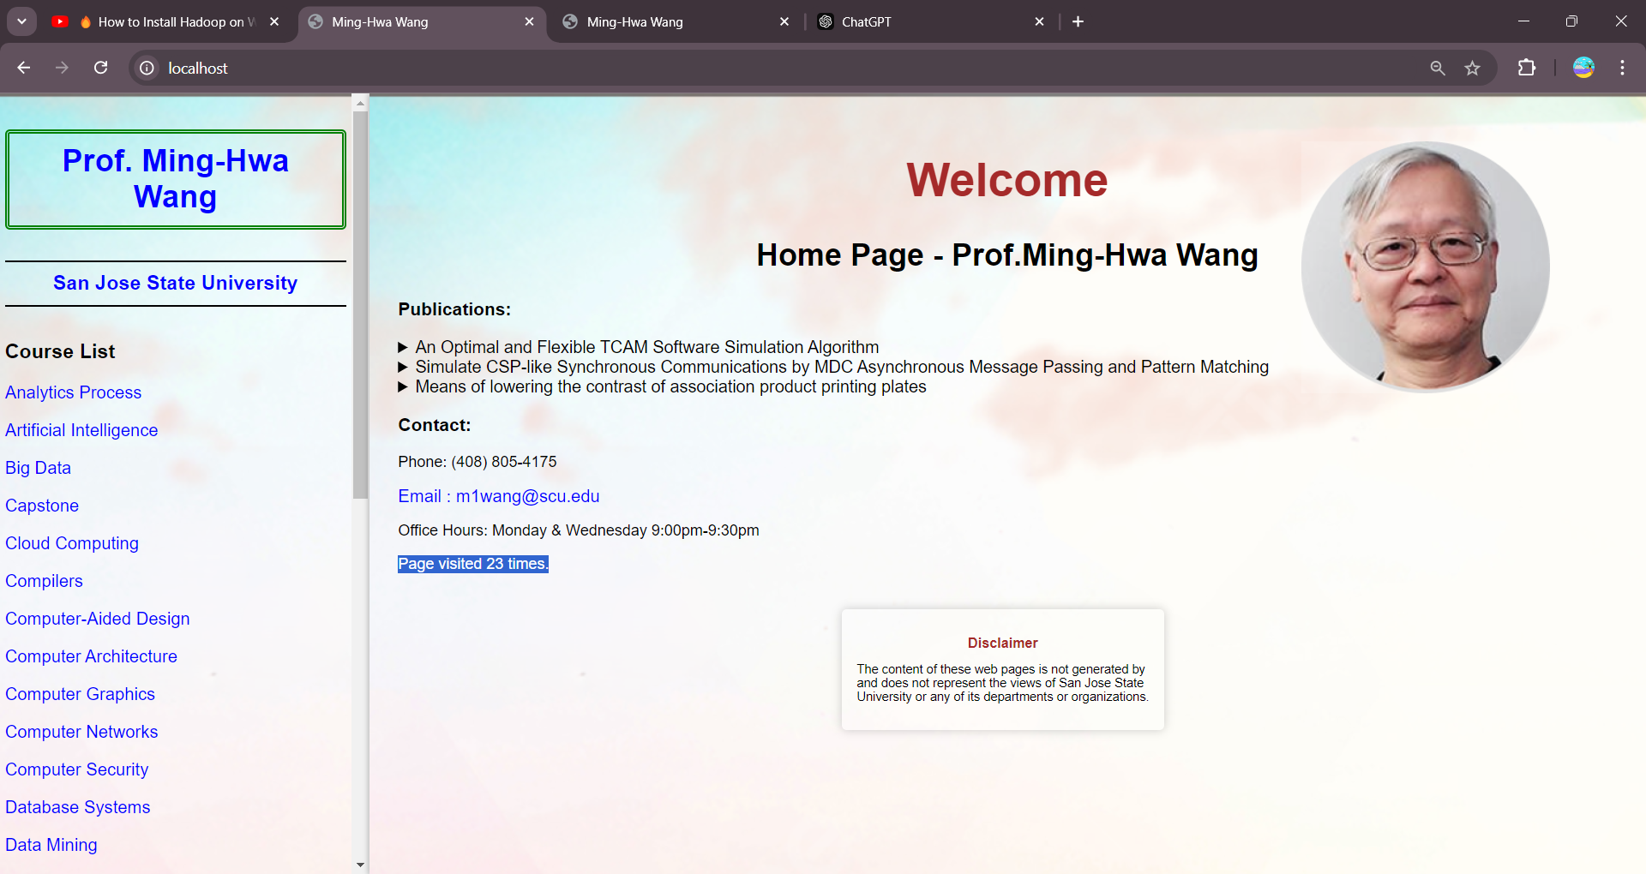

### Mouse Hovering:

